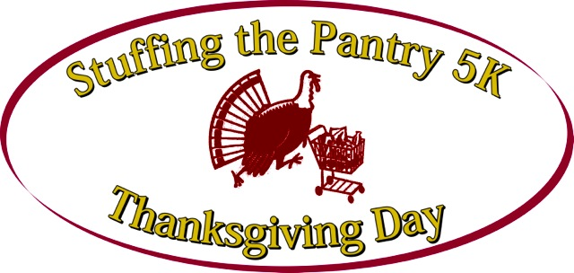

5K Run and Walk To Benefit the Open Pantry
Thanksgiving Week 2020
(Monday 11/23 through Sunday 11/29)

This year’s events will be done virtually due to the COVID-19 pandemic and public health and safety requirements. As a result of this public health crisis and related economic hardship, the needs being addressed by the Open Pantry have never been greater.

THANK YOU TO OUR 2019 LEAD SPONSORS
Wireless Zone
American Saw/LENOX
Health New England

Registration: Individual: $25.00 (age 18 and under $20.00) and a food donation

T shirt Pick-Up: at 4Run3, Center Square, East Longmeadow
Monday through Wednesday, November 23 – 25 from 11:00 a.m. to 6:00 p.m.

RACE APPLICATION
Mail To: Charlie Casartello, 118 Duxbury Lane, Longmeadow, MA 01106
CHECK APPROPRIATE BOX: 5K RACE ☐ WALK ☐ OFFICIAL USE:

LAST NAME

FIRST NAME

AGE ON: 11/23 GENDER

ADDRESS

CITY STATE ZIP

E-MAIL

T-shirt size: S M L XL XXL XXXL

WAIVER/RELEASE In consideration of accepting this entry to and allowing me to participate in the Stuffing the Pantry 5K Road Race and Walk, I, the undersigned, intending to be legally bound, for myself and my heirs, executors and administrators, hereby hold harmless from any damages, losses, or personal injury of any kind sustained during or in any way connected with or otherwise concerning my participation in the Stuffing the Pantry 5K Road Race or Walk, any one or any sponsors of this event, including but not limited to Open Pantry and their affiliates, and any individuals, employees or agents associated with such entities, and their representatives, successors and assigns; and further, I hereby waive and release and forever discharge such persons or sponsors of and from any and all claims, causes of action, judgments and rights for any losses and damages I may have, arising from any and all injuries, including death, losses or damages suffered by me in this event. I verify that I am physically fit and have trained sufficiently for the completion of this event. I hereby grant full permission to any one and all of the sponsors to use any photographs, videotapes, pictures or other likeness of me obtained in connection with this event to/ for any lawful purpose.

Participant's signature: ________________________________________Date:__________________
(Parent’s Signature Required if Participant is less than 18 years of age.) For More Information email chacasa@aol.com or check our website at www.stuffingthepantry.org

