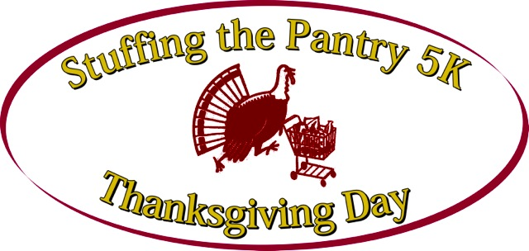
VOLUNTEER COMMITTEE

Ron Berger
Charlie Casartello
Tom Casartello
Colleen Cummings
Rosemary Dellarea
Arthur Grodd
Dave Haryasz
Tim Londo
Retired Chief Doug Mellis
Jill Murphy
Tim Murphy
Steve Penna
Gary Rappaport
Amy Ryan
Jim Sadowsky
Katie Sullivan
Joann Vallera

STUFFING THE PANTRY
5K ROAD RACE and 2M WALK

To Benefit the OPEN PANTRY

SPONSOR REGISTRATION FORM

YES. Please register me (or my company) as a Sponsor of the 2020 Stuffing the Pantry 5K Road Race and Walk.

- LEAD SPONSOR $2,000.00
- MAJOR SPONSOR $1,000.00
- SPONSOR $500.00

_________________________________________________________
Signature

_________________________________________ _________________________________________
Name Company

_________________________________________ _________________________________________
Address, City, State Zip Contact Telephone Number

Please make your check payable to “Stuffing the Pantry”. Mail Sponsor Registration Form and check to:

Charlie Casartello
STUFFING THE PANTRY RR
118 Duxbury Lane
Longmeadow, MA 01106

For more information, contact Charlie Casartello at 413-531-8773 or see our website: www.stuffingthepantry.org.

